**BEETLE GAME REPORT,** part 1

By …

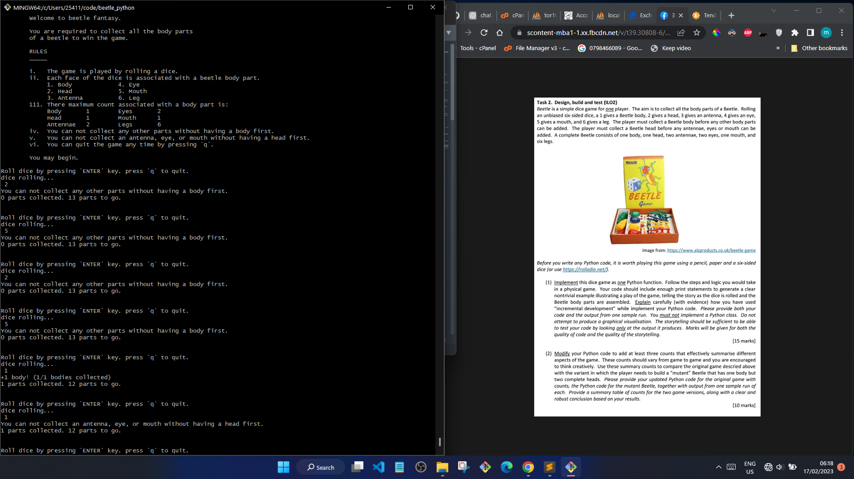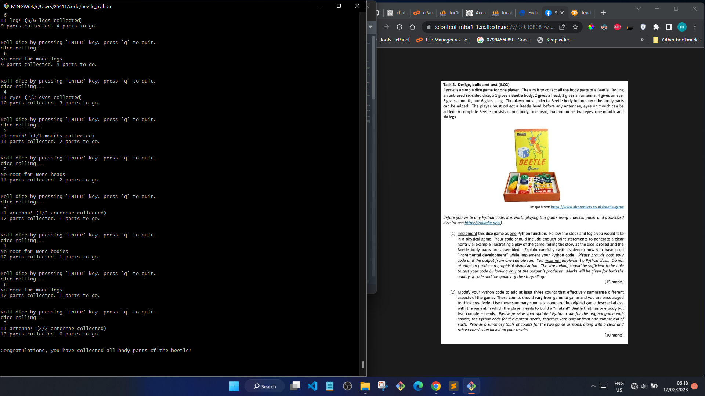

While developing the game, I employed the incremental development approach to develop the features. I first started by defining the constant variables that were provided in the question. The variables include: MAX_LEGS, MAX_ANTENNA, etc. The variables were supposed to be used to tell whether all the body parts were collected. Next, I implemented the ability to roll a dice. This was done using the random library to generate a random integer between 1 and 6.

Afterwards, I created the loop control structure (while loop) which would exit the game when key ‘q’ was pressed or when all the body parts were collected successfully. This was done by introducing a boolean variable ‘beetle_complete’ and an int variable ‘ALL_PARTS_COUNT’ which were constantly checked and compared to tell whether the game was complete.

Now that the basic skeleton was done, I started designing the logic that would assign a body part to a number rolled on the die. Each body part was assigned a unique number. Controls were also added at this point to ensure that the major parts, ‘body’ and ‘head‘ were prioritized and everything should be added according to importance.